April Monthly Activities Report in respect of Manipur State

Criteria | Details
Sector | PACS/StCB/Dairy/Fisheries etc.
Location | RCS Office Imphal, Kamjong District.
Event/Activity Name | 1. Tree plantation drive in support of the “EK Ped Maa Ke Naam” campaign at the premises of RCS, Manipur.  2. Farmers Training Scientific Piggery Farming &Cattle Rearing at Kamjong District
Brief Information on the Activity | 1.Tree plantation programme to promote environmental sustainability and underscore the cooperative sectors commitment to green and inclusive development at RCS Office, Lamphelpat.  2. Senstization programme on Farmers Training Scientific Piggery Farming &Cattle Rearing was held on 23rd April in collaboration with District Veterinary Office, kamjong at Kamjong District.
Objective | To enhance the economic conditions of the people specially the rural section of the population in the State through promotion of Cooperative Movement and also to spread awareness of the initiatives of Ministry of Cooperation, Government of India to the general mass.
No. of Participants | 350
Achievements & Outcomes | - Around 100 tree saplings were planted at the premises of RCS office, Lamphelpat  - Significant achievements, equipping farmers with knowledge and skills to improve their livelihoods. These programs cover essential aspects like animal husbandry, health management, breeding techniques, and efficient farm management, leading to improved productivity and profitability in pig farming and cattle rearing Cooperative Societies
Photographs & AV Content  1. Tree plantation drive in support of the “EK Ped Maa Ke Naam” campaign at the premises of RCS, Manipur. | 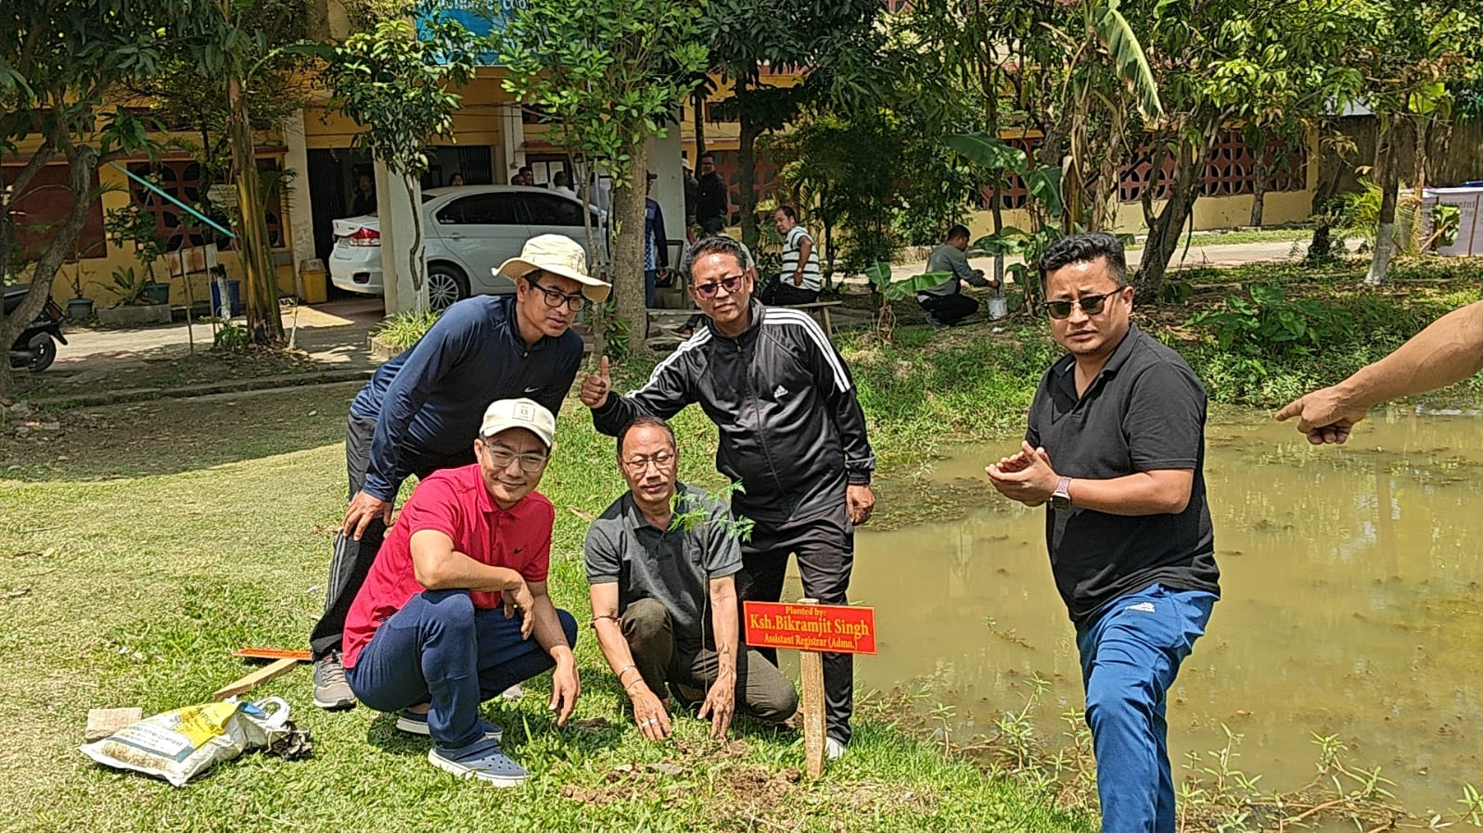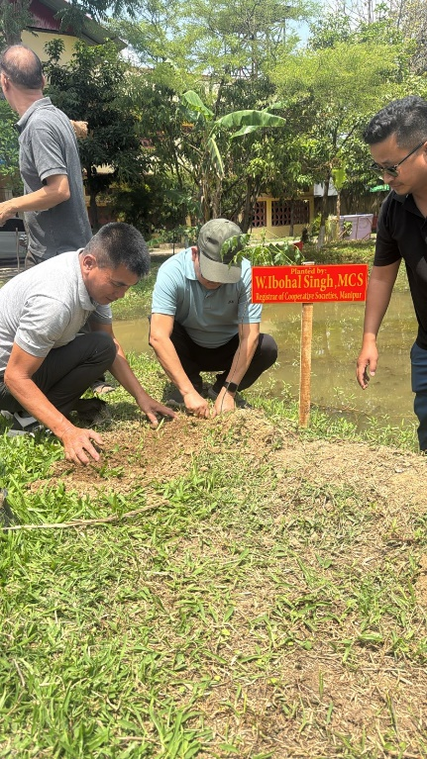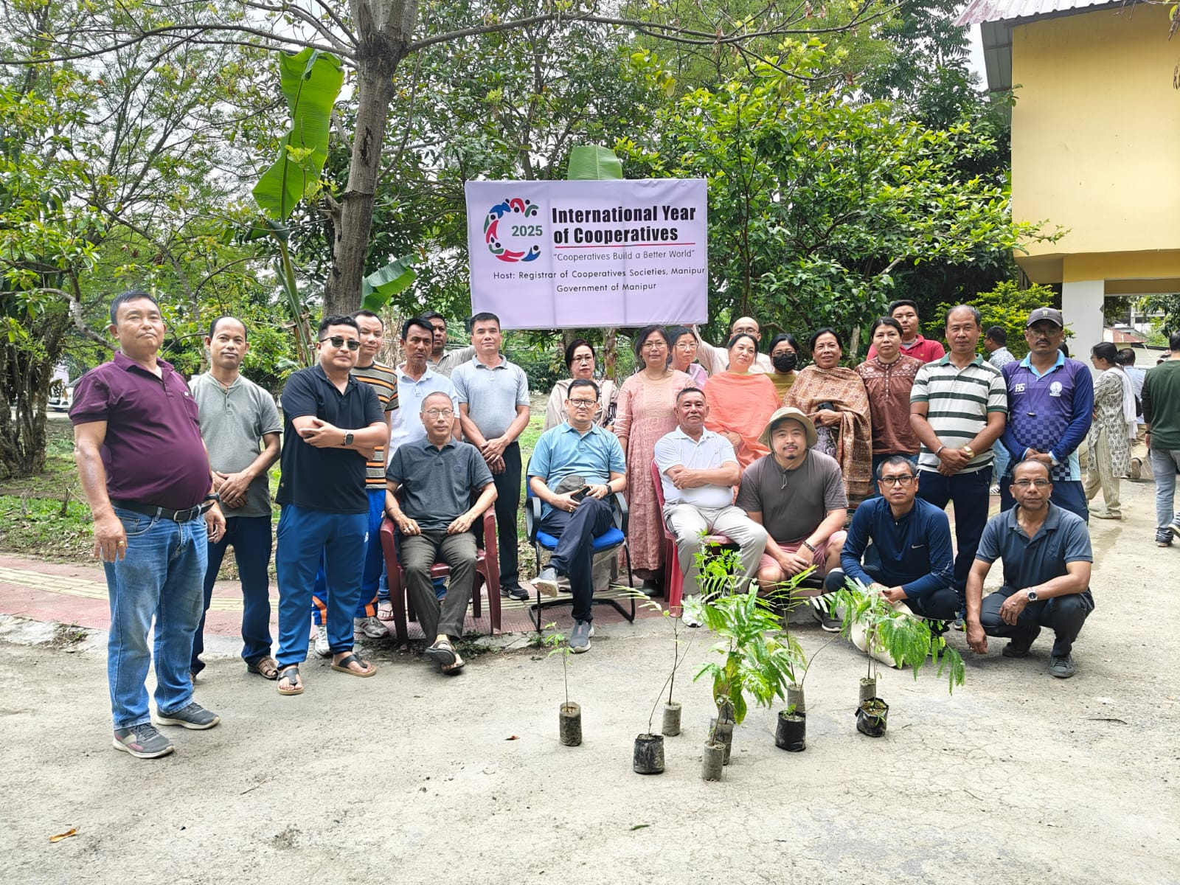
2. Farmers Training Scientific Piggery Farming &Cattle Rearing at Kamjong District | 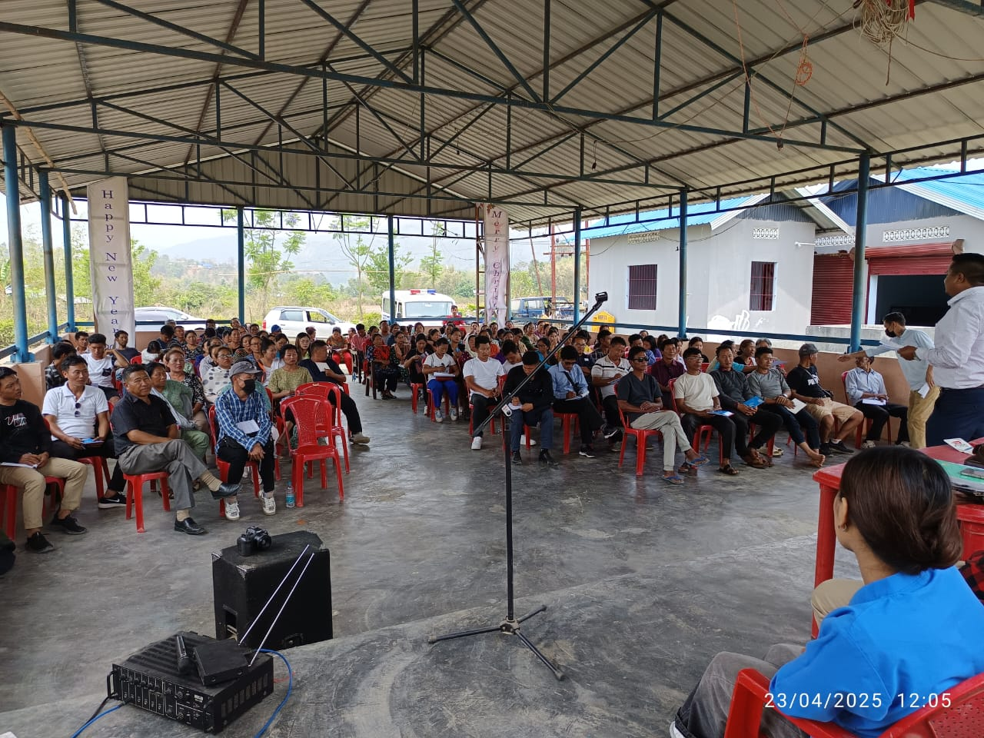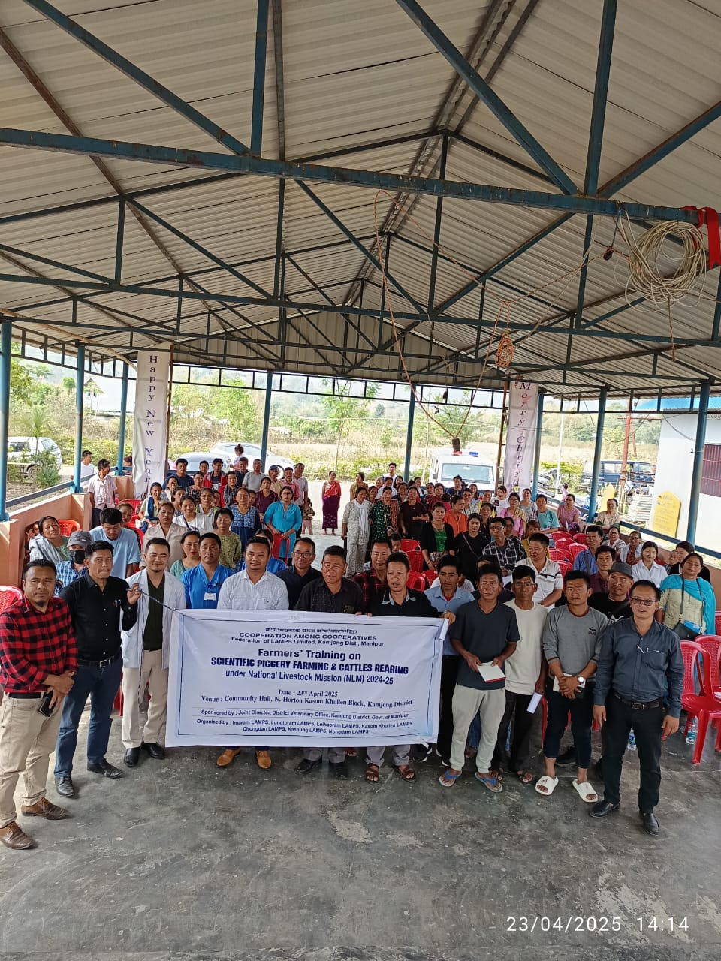
Additional Remarks

