February Monthly Activities Report in respect of Manipur State

Criteria | Details
Sector | PACS/StCB/Dairy/Fisheries etc.
Location | Kakching District, Thoubal District, Tengoupal District, Senapati District, ICM Imphal
Event/Activity Name | 1. A One-Day District-Level Awareness Programme on PMMSY, FIDF, and LIFIC at Kakching District.  2. Workshop and awareness programme on Cooperation among Cooperative at Tengoupal District.  3. C-PEC Training Programme to do existing business better in post reform scenario at ICM Imphal.  4. One day work shop on Cooperation among Cooperative at Senapati District.  5. One day work shop on Cooperation among Cooperative.at Tengoupal district  6. One day work shop on Cooperation among Cooperative at Thoubal District
Brief Information on the Activity | 1. District Level Awareness programme on PMMSY, FIDF & LIFIC for Fisheries/Pisciculture Cooperative Societies.  2. Awareness programme was held on Principles of Cooperatives & role of PACS in Rural Development, benefits of KCC Loan to the members of the PACS.
Objective | To enhance the economic conditions of the people specially the rural section of the population in the State through promotion of Cooperative Movement and also to spread awareness of the initiatives of Ministry of Cooperation, Government of India to the general mass.
No. of Participants | 500
Achievements & Outcomes | - Role of NCDC in the Development of Fisheries Cooperatives Across the Country  - Awareness of the Role of the Department of Fisheries & NCDC through the Implementation of Various Financial Assistance Schemes, including PMMSY and FIDF  - Awareness of the FFPO Scheme, PM-MKSSY, and LINAC Fisheries Business Incubation Centre (LIFIC): Its Significance, Application Procedure, and Benefits  - Sharing the idea of cooperation among the members of the Society and how to get KCC loan from the concerned bank through PACS and opening of bank account of various Cooperative Societies at StCB. Members of the Society were motivated after speech delivered by the delegates.
Photographs & AV Content  1. One-Day District-Level Awareness Programme on PMMSY, FIDF, and LIFIC at kakching District | 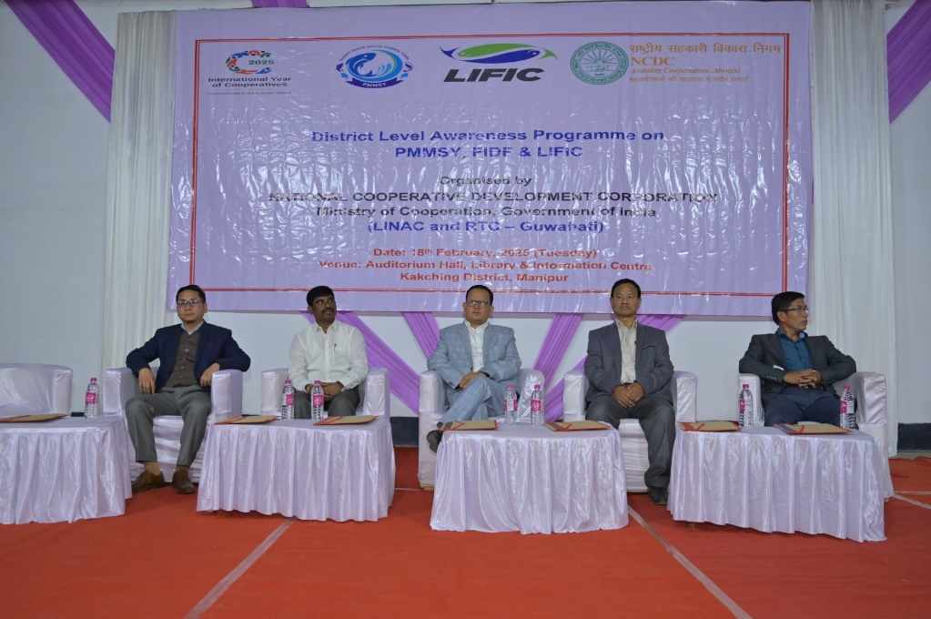  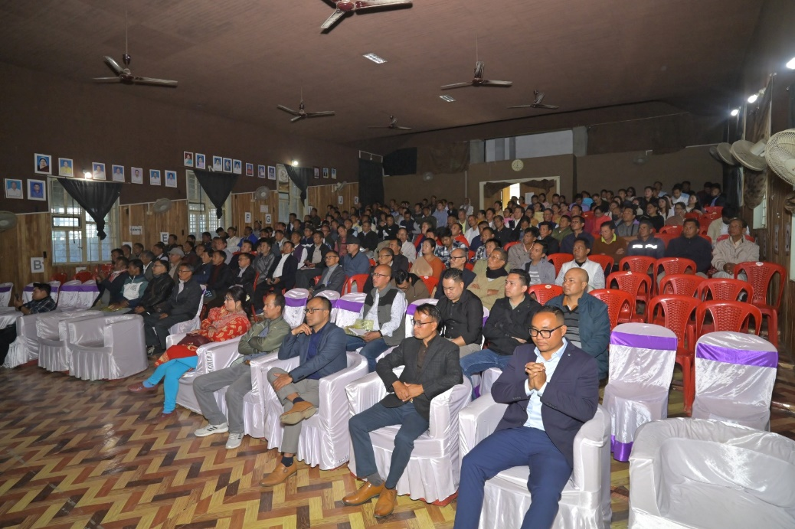
2. One day work shop on Cooperation among Cooperative at Tengoupal District | 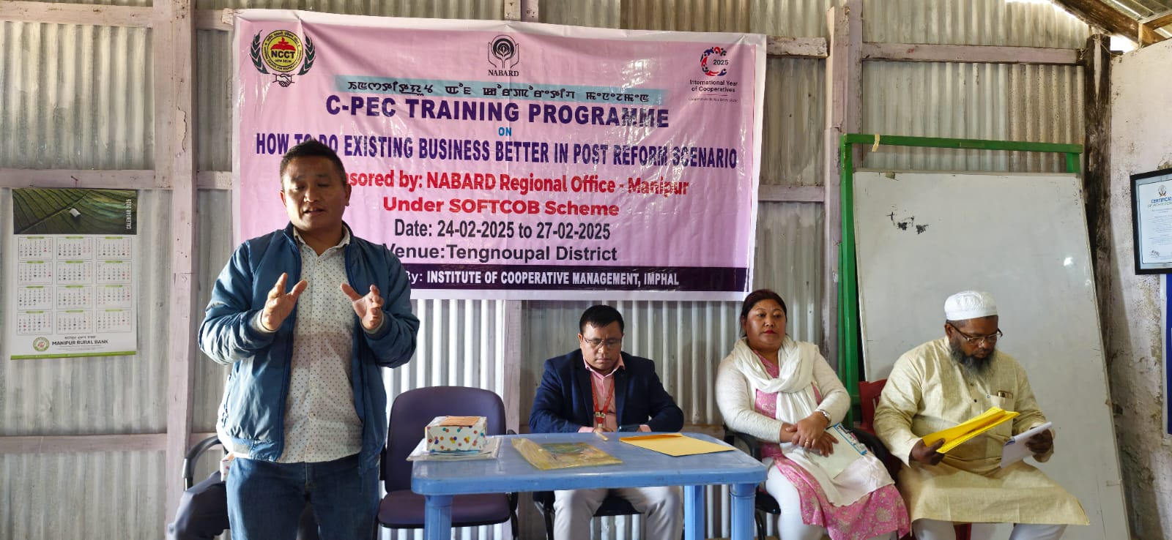  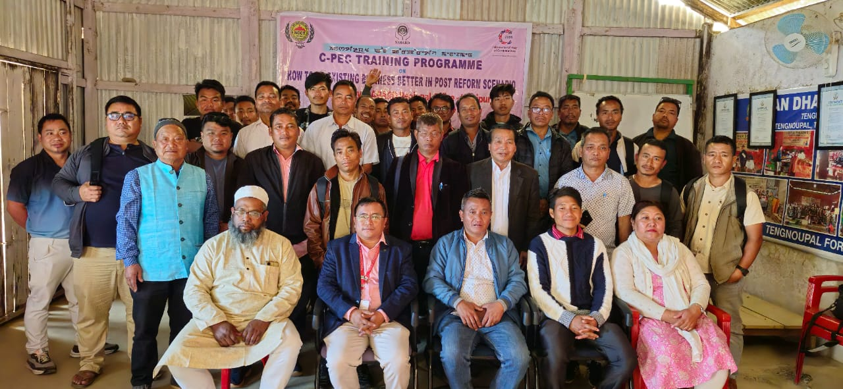  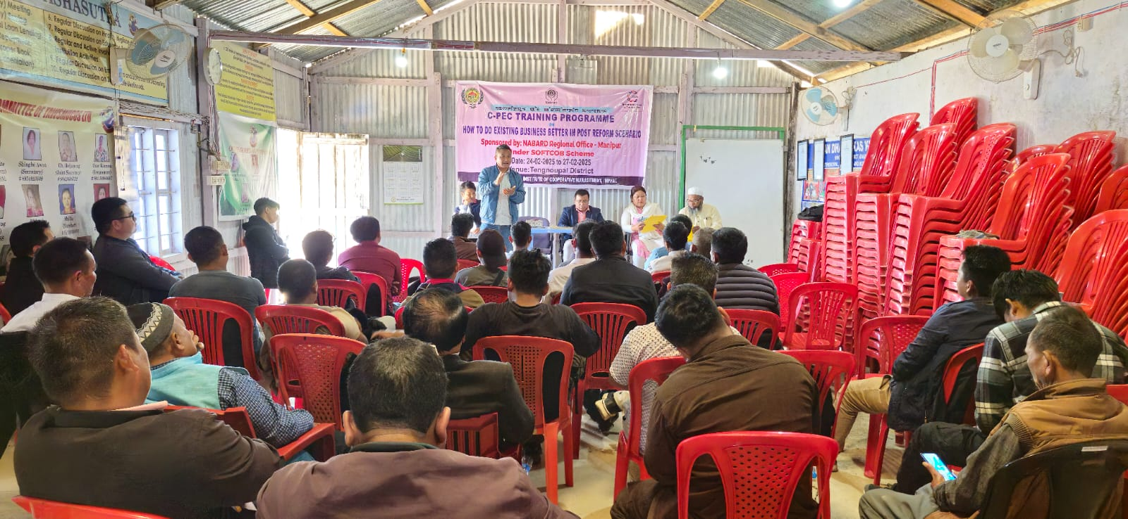
3. C-PEC Training Programme to do existing business better in post reform scenario at ICM Imphal. | 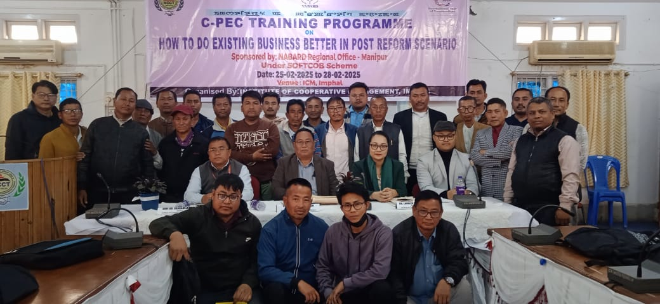
4. One day work shop on Cooperation among Cooperative at Senapati District. | 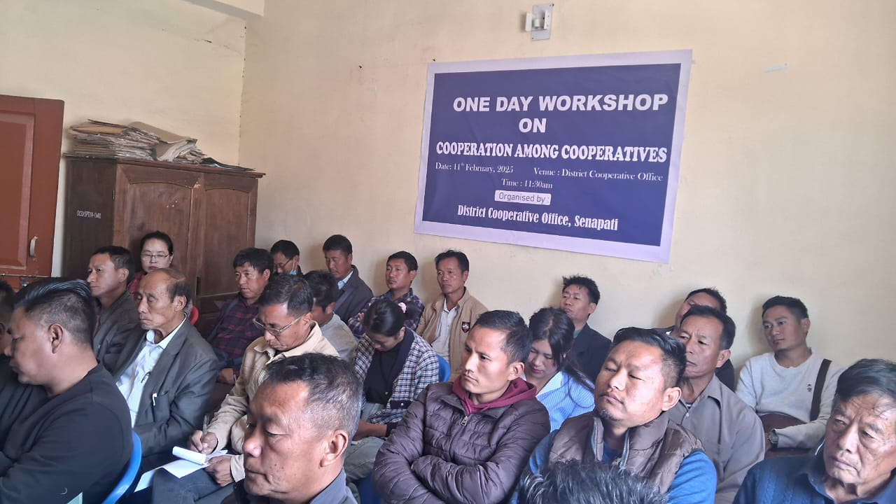
5.One day work shop on Cooperation among Cooperative.at Tengoupal district | 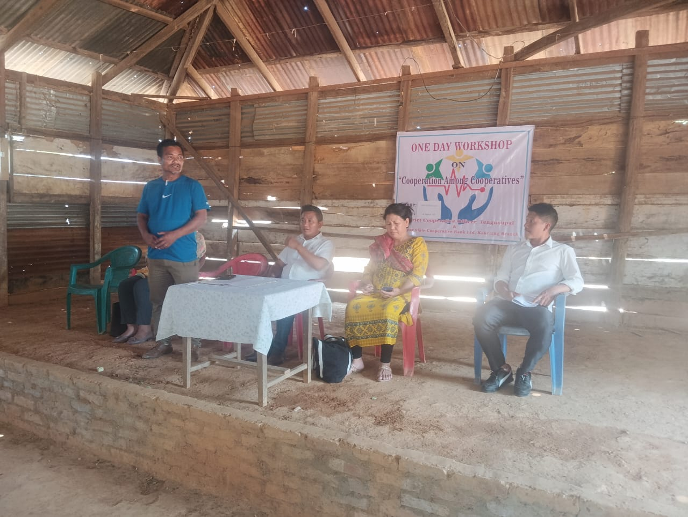  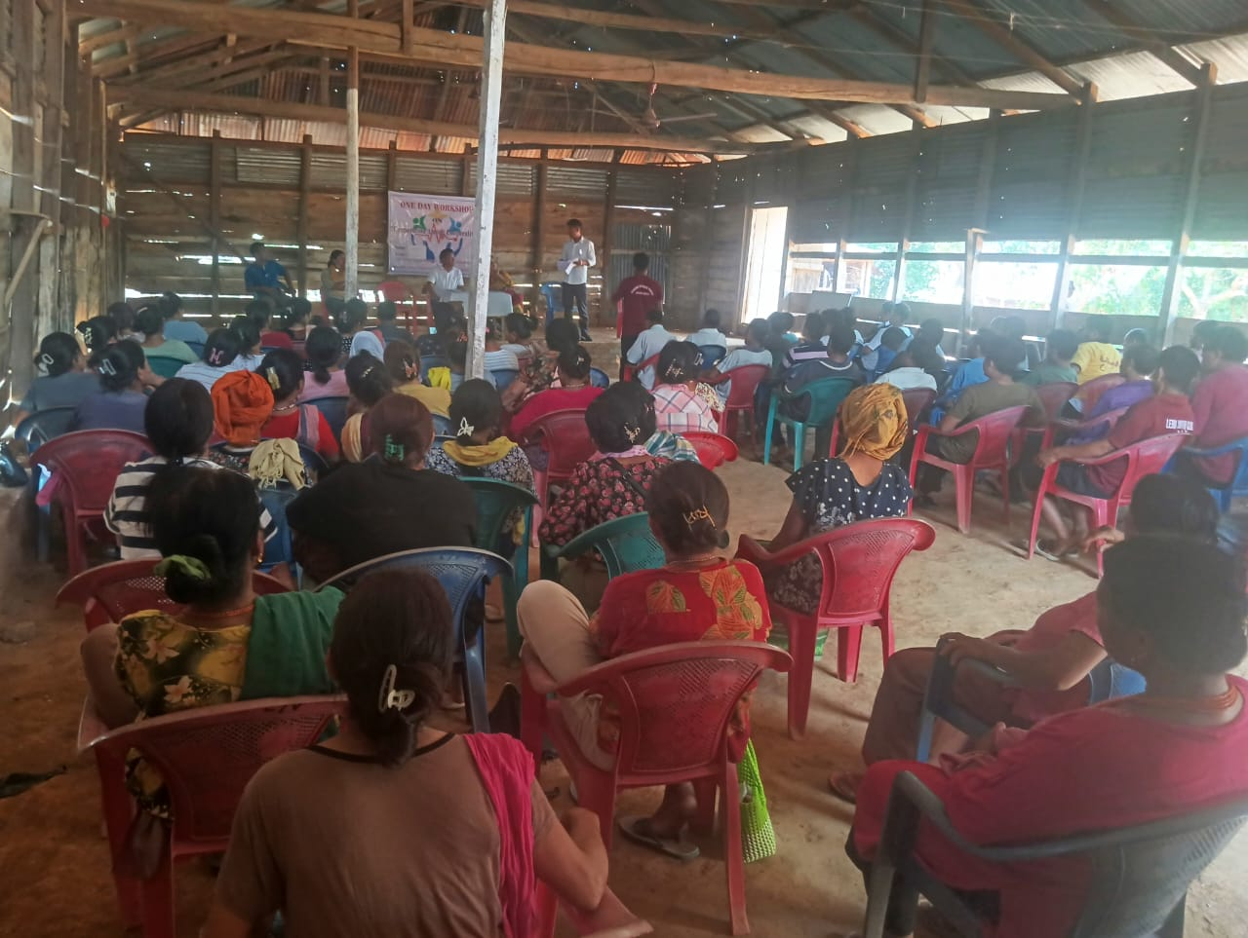
6. One day work shop on Cooperation among Cooperative at Thoubal District. | 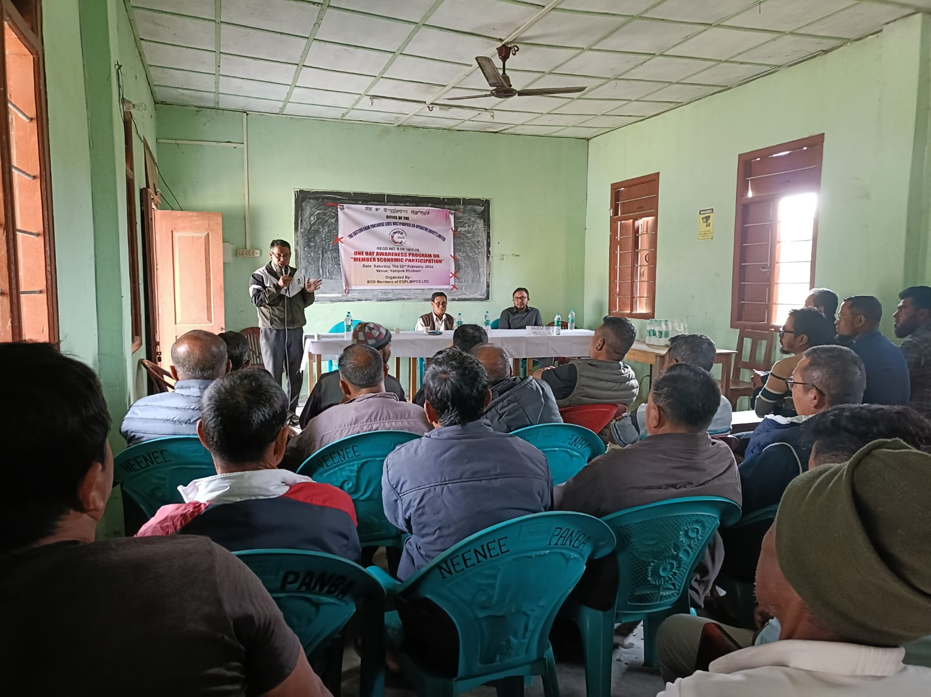
Additional Remarks

