March Monthly Activities Report in respect of Manipur State

Criteria | Details
Sector | PACS/StCB/Dairy/Fisheries etc.
Location | Kamjong District, Imphal East District, Tengoupal District.
Event/Activity Name | 1. One day work shop on Cooperation among Cooperative at Kamjong District  2. One day work shop on Cooperation among Cooperative at Tengoupal District  3. One day work shop on Cooperation among Cooperative on Development of Fishery Cooperative Societies at Imphal East District  4. One day work shop on Cooperation among Cooperative at Imphal East District  5. One day work shop on Financial Literacy Awareness programme cum KCC Credit Linkage at Imphal East District.  6.C -PEC Training Programme to do existing business better in post reform scenario at Tengoupal District
Brief Information on the Activity | 1. Awareness programme was held on Principles of Cooperatives & role of PACS in Rural Development, benefits of KCC Loan to the members of the PACS.  2. Senstization programme on various initiatives of Ministry of Cooperation, Government of India.
Objective | To enhance the economic conditions of the people specially the rural section of the population in the State through promotion of Cooperative Movement and also to spread awareness of the initiatives of Ministry of Cooperation, Government of India to the general mass.
No. of Participants | 330
Achievements & Outcomes | - Sharing the idea of cooperation among the members of the Society and how to get KCC loan from the concerned bank through PACS and opening of bank account of various Cooperative Societies at StCB. Members of the Society were motivated after speech delivered by the delegates.
Photographs & AV Content  1. One day work shop on Cooperation among Cooperative at Kamjong District | 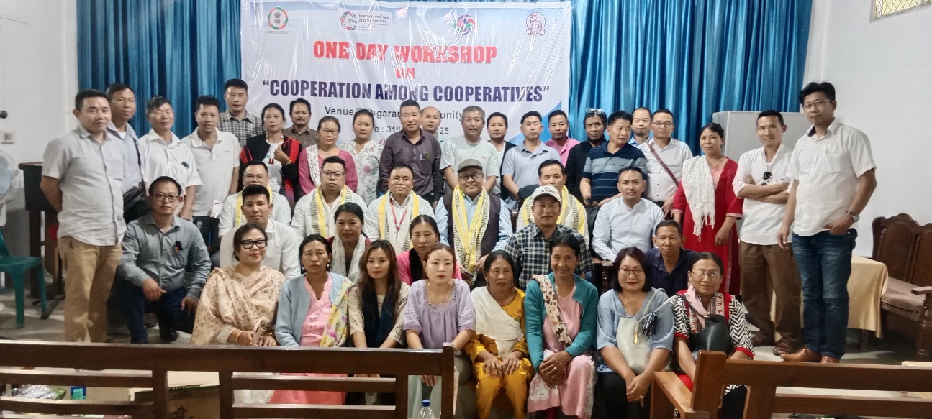
2. One day work shop on Cooperation among Cooperative at Tengoupal District | 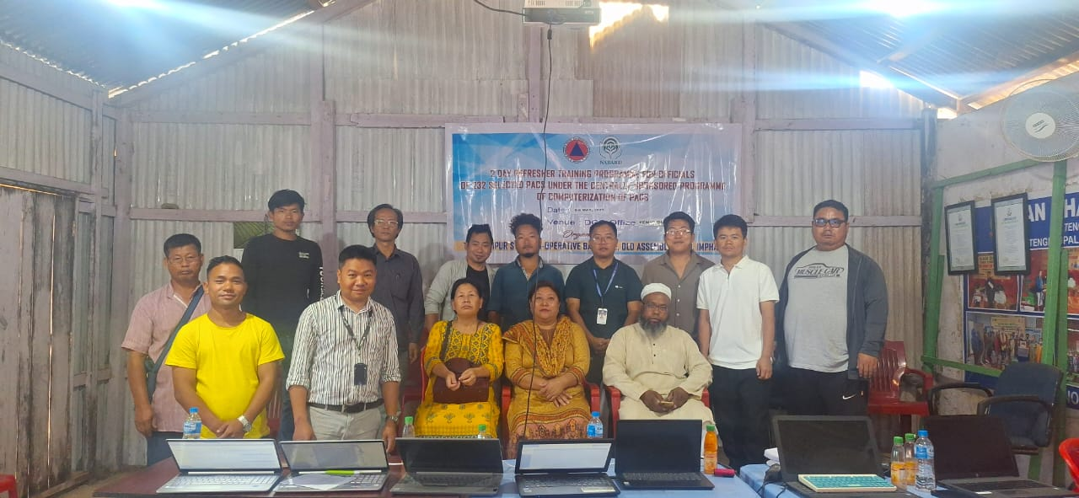
3. One day work shop on Cooperation among Cooperative on Development of Fishery Cooperative Societies at Imphal East District | 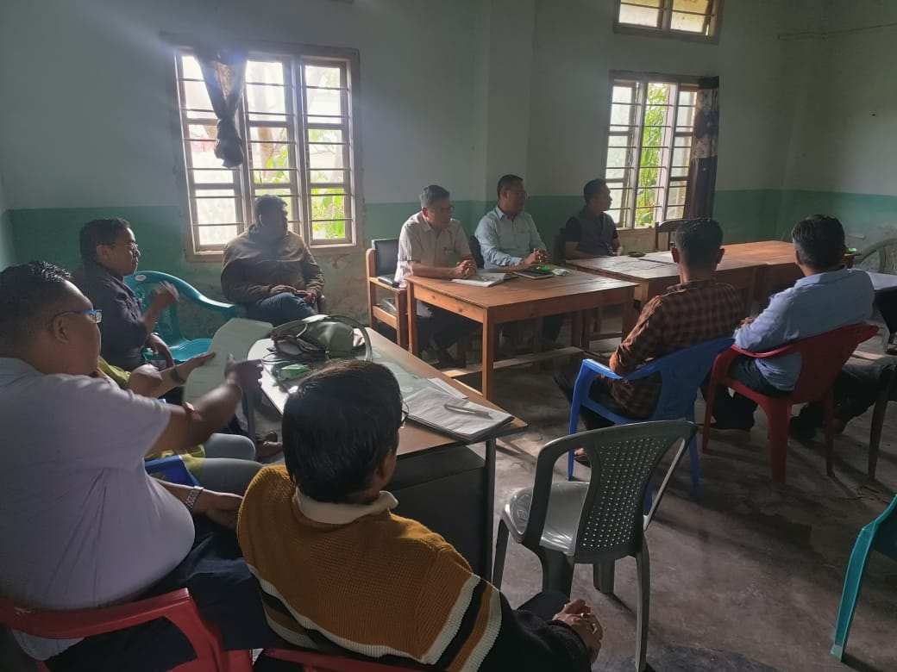
4. One day work shop on Cooperation among Cooperative and door to door camps for opening Bank Account at Imphal East District | 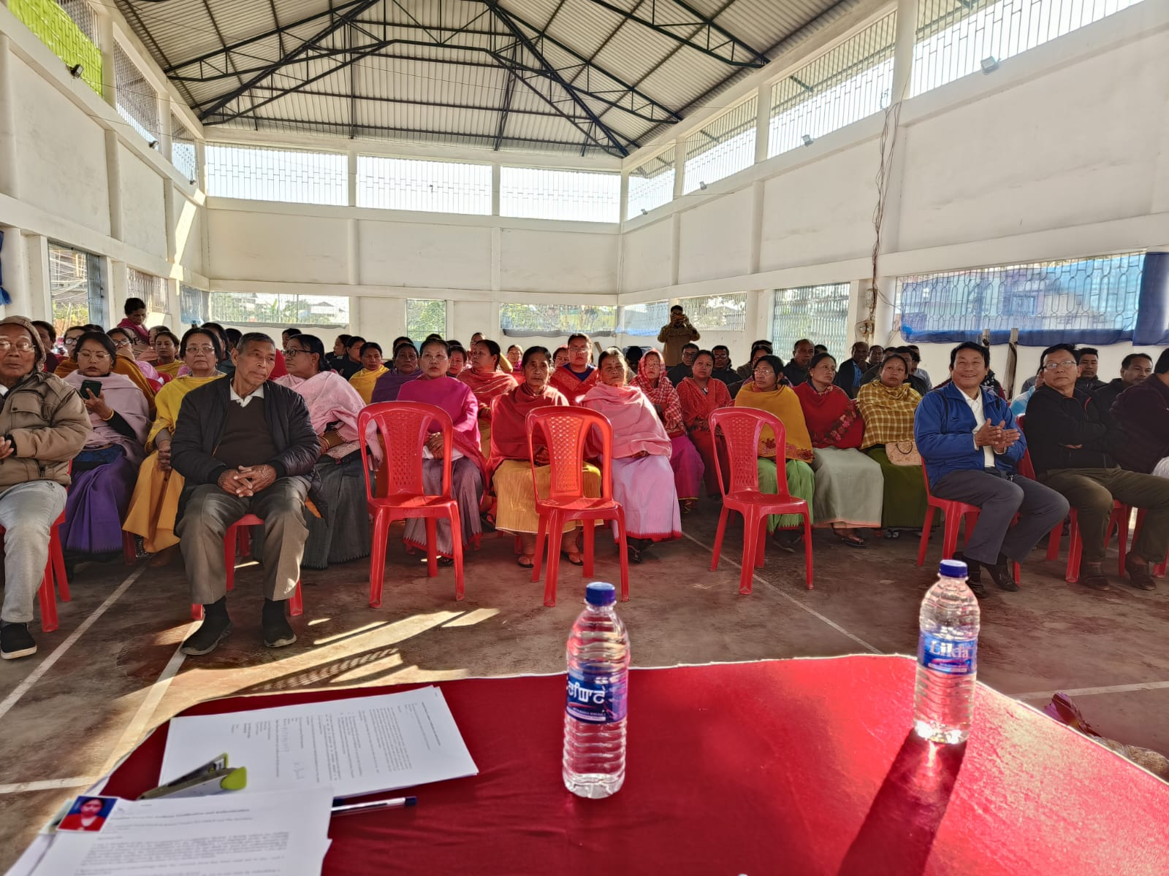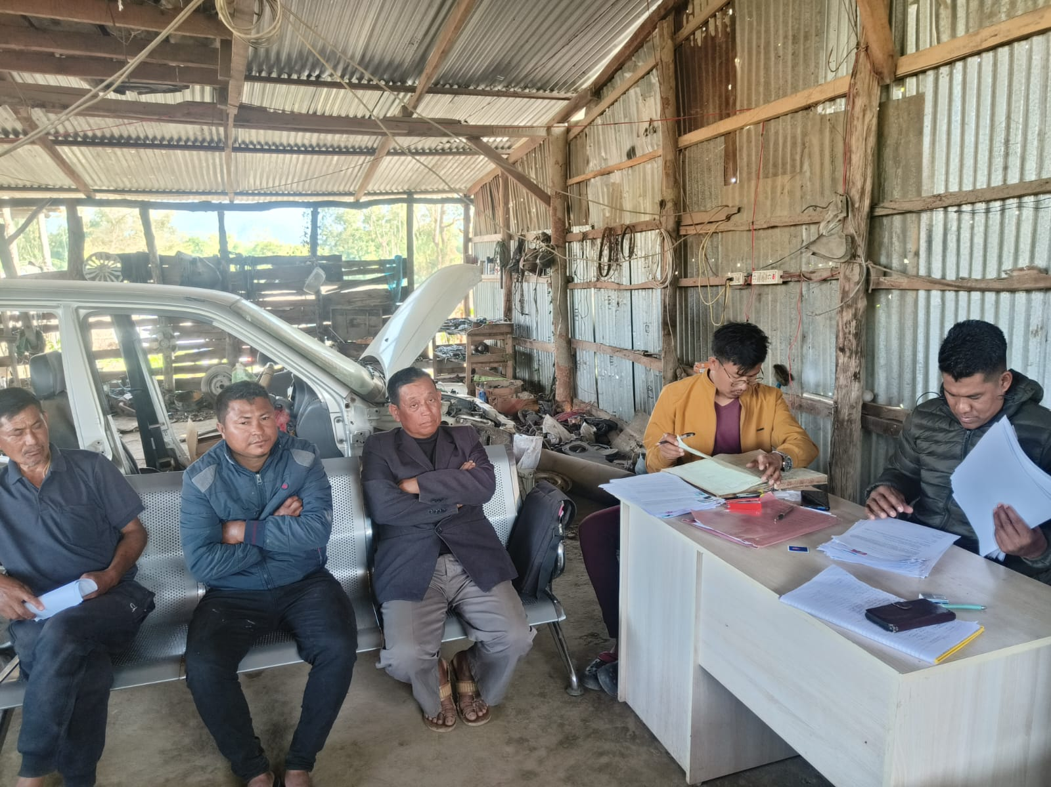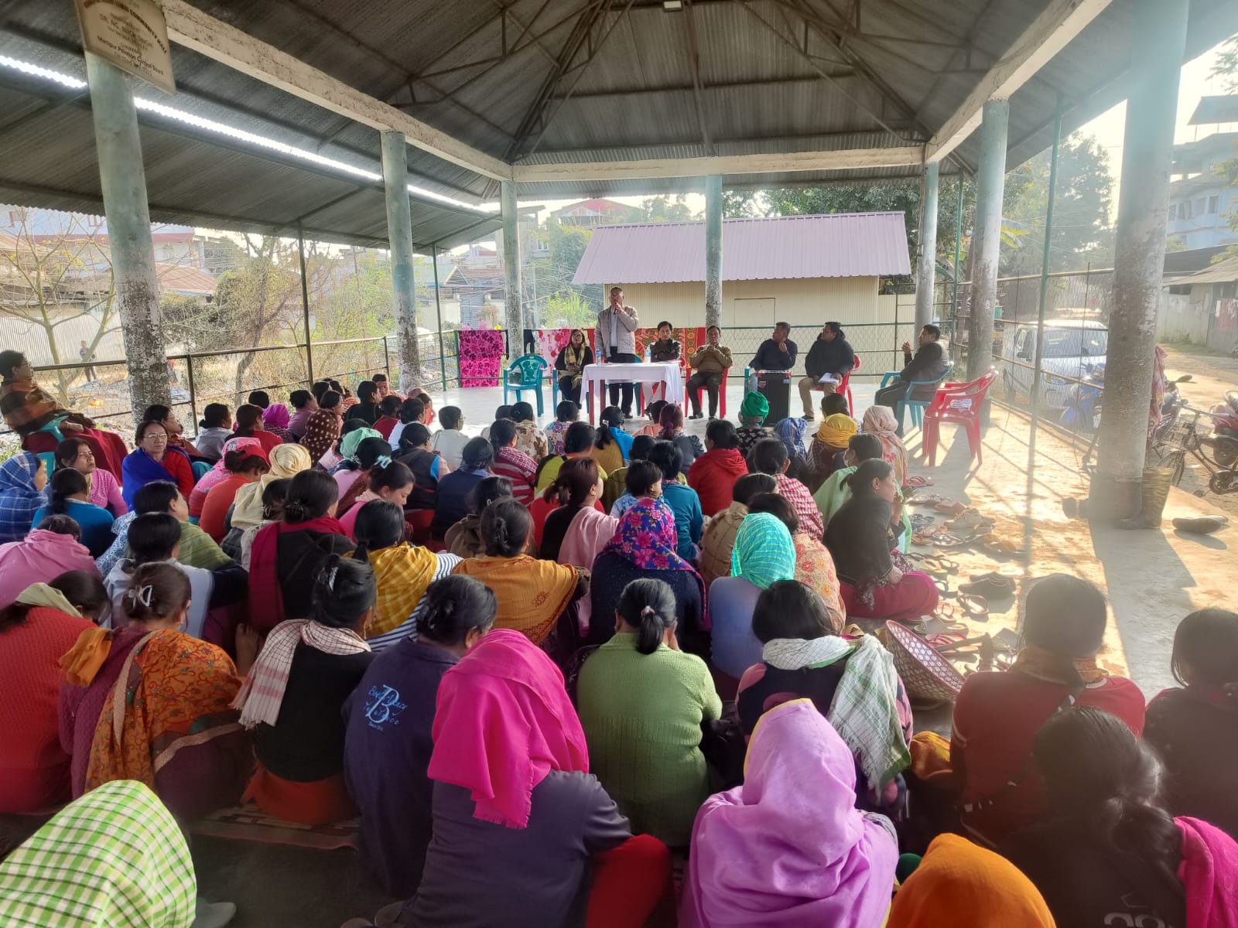
5. One day work shop on Financial Literacy Awareness programme cum KCC Credit Linkage at Imphal East District. | 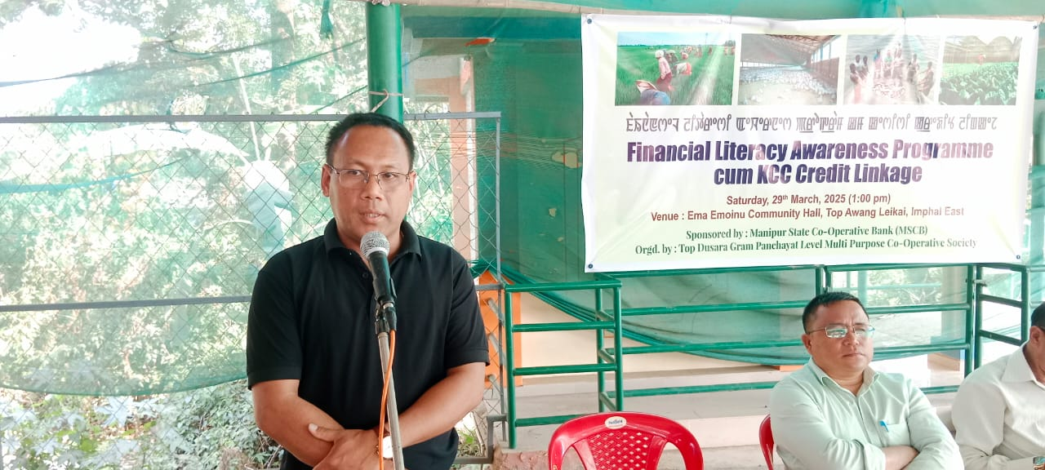  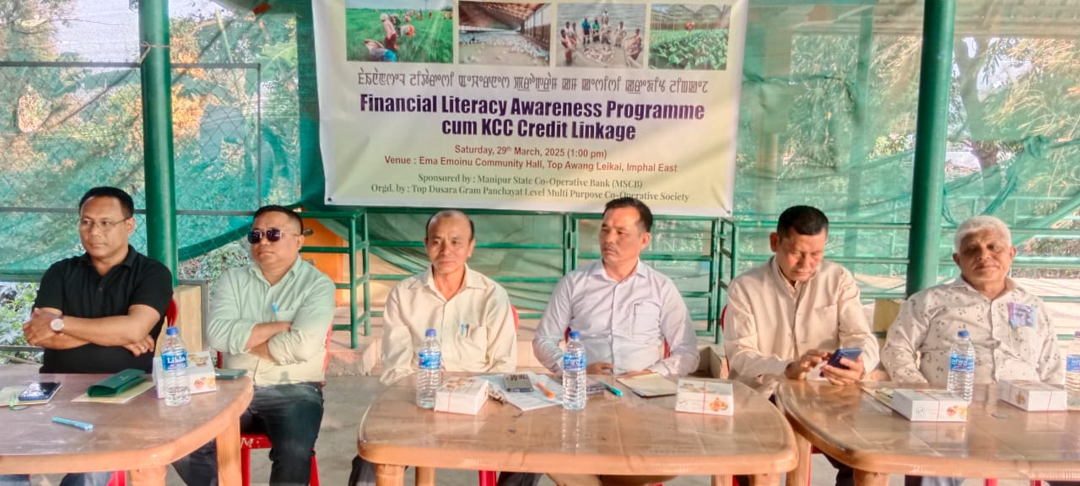
6. C-PEC Training Programme to do existing business better in post reform scenario at Tengoupal District. | 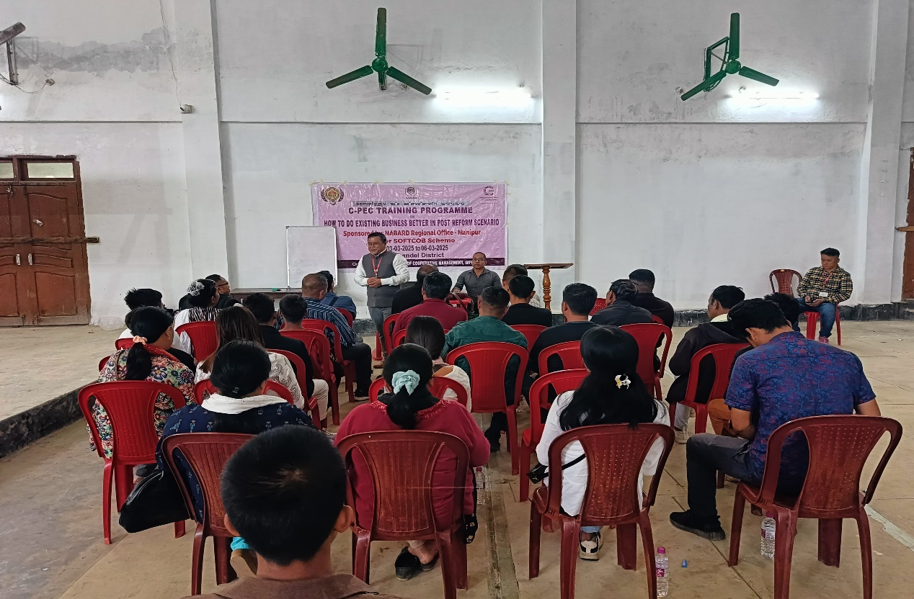
Additional Remarks

